BEYOND QRIS ADOPTION: CONVERTING DIGITAL PAYMENT ACCESS INTO SCALABLE MSME OUTCOMES IN INDONESIA

Author: Albert Yansen
Email: albert.yansen@gmail.com

Abstract
This study examines whether the rapid expansion of Indonesia’s Quick Response Code Indonesian Standard (QRIS) has created the conditions required for micro, small, and medium enterprise (MSME) scalability. It integrates national indicators for 2020–2025, provincial merchant distribution as of 30 June 2025, quarterly consumer adoption, and QRIS transaction volume and value. A quantitative descriptive-correlational and policy-diagnostic design is employed using trend analysis, year-on-year growth rates, exploratory Pearson correlations, the Herfindahl-Hirschman Index, the Gini coefficient, and a provincial merchant-ecosystem typology.
The findings show that registered QRIS merchants increased from 13 million in 2020 to 43 million in 2025, while consumer users reached approximately 60 million by the fourth quarter of 2025. In the second quarter of 2025, QRIS processed 1.19 billion transactions worth Rp110 trillion, representing year-on-year growth of 141 percent in volume and 111 percent in value. Merchant expansion was strongly associated with MSME credit and financial literacy, although the short annual series and estimated 2025 MSME values preclude causal interpretation. Provincial adoption was also highly concentrated: the ten largest provincial networks accounted for 79.41 percent of merchants, with an HHI of approximately 1,048 and a Gini coefficient of 0.685.
The study contributes an access–usage–capability–scale framework that distinguishes merchant registration from productive digital empowerment. It concludes that QRIS provides essential payment infrastructure, but MSME scalability depends on active usage, financial-management capability, responsible financing, merchant protection, consent-based data governance, and regionally differentiated implementation.

Keywords: QRIS; MSME scalability; digital financial inclusion; financial capability; regional concentration
JEL classification: E42; G28; O16; O33

1. Introduction
Digital finance has become a core instrument in Indonesia's strategy for inclusive financial-sector development. The rapid diffusion of mobile banking, e-wallets, and interoperable payment systems has changed how firms receive, store, and transfer money. QRIS is particularly important because it creates a unified QR payment standard across participating providers (BI, 2024). For MSMEs, the system lowers the cost of accepting non-cash payments and makes small transactions more visible to the formal financial ecosystem.
The Karisma OJKI 2026 theme, 'Empowering MSMEs in the Digital Ecosystem to Accelerate Economies of Scale', requires analysis that goes beyond digital adoption as a headline achievement. MSME empowerment is not completed when a merchant receives a QR code (OJK, 2026). Digital infrastructure becomes economically meaningful only when MSMEs use it to improve liquidity management, strengthen transaction documentation, access appropriate finance, reach more consumers, and scale without proportionally increasing costs.
This distinction is central to the present study. QRIS can expand quickly because onboarding is administratively simple and does not require the same investment as conventional point-of-sale infrastructure. MSME capability develops more slowly because it depends on financial literacy, bookkeeping discipline, data security awareness, loan-readiness, business planning, and trust in formal financial institutions (OJK, 2024a). The policy risk is that a country may achieve impressive digital-payment access while many small firms remain unable to convert that access into productivity, creditworthiness, and economies of scale.
The study therefore examines the access-capability gap in Indonesia's QRIS-MSME ecosystem. It first evaluates national movements in QRIS merchants, financial literacy, financial inclusion, MSME credit, and MSME counts from 2020 to 2025. It then extends the analysis to provincial QRIS merchants and provincial internet access in 2025. This provincial layer is added to address a weakness in purely national analysis: a five-year time series can describe broad trends, but it is too short to support strong statistical claims. Cross-provincial analysis helps identify regional variation and strengthens the policy interpretation.
The paper does not claim that QRIS causes MSME credit growth or business scalability. Its contribution is more precise: it assesses whether payment access, financial capability, financing indicators, and digital connectivity move in compatible directions, and it identifies where the gaps are most visible. This framing is more useful for regulation because it separates access, usage, readiness, and scale instead of treating merchant registration as empowerment in itself.

1.1 Research Gap
Existing MSME finance literature explains why smaller firms face financing constraints: asymmetric information, collateral limitations, weak financial records, and high monitoring costs can reduce lenders' willingness to provide credit (Arner et al., 2020; Voordeckers & Steijvers, 2006; Berger & Udell, 2006; Petersen & Rajan, 1994; Weiss, 1981). Digital financial services can partly reduce these constraints by lowering transaction costs and generating data footprints (Murfin & Spiegel, 2020; Frame et al., 2001; Jagtiani & Lemieux, 2019; ). However, the Indonesian QRIS literature remains dominated by local case studies, user-perception surveys, and descriptive policy reporting. These works are useful but often do not connect QRIS adoption with national MSME financing, capability indicators, and regional digital access in a single empirical narrative.
A second gap concerns the interpretation of inclusion. Policy reports commonly emphasize the number of users, accounts, or merchants. This is understandable because access metrics are measurable and politically visible. Yet effective inclusion requires informed, repeated, safe, and productive use. An MSME that has QRIS but cannot reconcile settlement records, separate personal and business funds, compare loan products, or protect its digital account is formally included but economically underprepared. This study addresses that gap by combining access indicators with capability, financing, and connectivity evidence.

1.2 Research Questions and Objectives
The study answers four questions. First, how did QRIS merchants, financial literacy, financial inclusion, MSME credit, and MSME counts evolve in Indonesia from 2020 to 2025? Second, how strong is the association between QRIS merchant expansion and selected MSME-related financial indicators? Third, how concentrated is QRIS merchant distribution across provinces in 2024? Fourth, how does provincial QRIS merchant distribution relate to provincial internet access, and what does this relationship imply for capability-based inclusion policy?
The objectives are to document digital financial inclusion trends, calculate growth rates and correlations, evaluate regional concentration, construct a provincial digital-readiness typology, and translate the findings into operational policy recommendations for regulators, financial institutions, payment service providers, and MSME development agencies.

1.3 Contribution of the Study
This paper contributes in four ways. First, it focuses on QRIS as a specific Indonesian digital payment infrastructure, rather than treating digital finance as a broad category. Second, it applies an access-capability gap framework to distinguish registration, use, readiness, and scalability. Third, it strengthens national trend analysis with provincial evidence on QRIS distribution and internet access. Fourth, it converts empirical patterns into policy instruments: QRIS-based credit readiness, consent-based transaction-data portability, applied financial literacy, merchant protection, and geographically targeted intervention.

2. Literature Review

2.1 Digital Financial Inclusion and QR-Based Payments
Digital financial inclusion refers to effective access to and use of formal financial services through digital channels by individuals and firms that were previously underserved. This concept is broader than account ownership because it requires usability, affordability, safety, and repeated use (Allen et al., 2016; BECK et al., 2005; Demirguc-Kunt & Klapper, 2012). Digital channels can reduce distance costs, expand service availability, and lower some transaction frictions (Arner et al., 2020; Gomber et al., 2018). For small merchants, digital payments can also create records that cash transactions do not generate. These records may support financial planning and credit assessment if they are reliable, portable, and connected to formal financial products.
QR-based payment systems are especially relevant for micro and small merchants because they require less hardware than card-based systems. A merchant can accept payment through a static or dynamic code, while consumers can pay through banks or non-bank payment applications. QRIS adds interoperability: one standard code can be accepted across participating providers. This design reduces fragmentation and supports network effects in retail payments, which is consistent with broader evidence that digital payments can reduce transaction costs and create new inclusion channels (BI, 2024; BECK et al., 2005; Jack & Suri, 2014; Suri, 2017; Suri & Jack, 2016).
However, digital financial inclusion should not be measured only by the number of registered merchants or users. Effective inclusion requires repeated use, informed choices, safety, and economic usefulness. Digital access can also create risks if users do not understand fees, settlement timing, fraud, complaint channels, and data use. For MSMEs, the key question is not only whether merchants can receive QRIS payments, but whether they can use QRIS to manage liquidity, build credible records, access finance, and grow.

2.2 MSME Scalability and Access to Finance
MSME scalability is the ability of a firm to expand sales, operations, market reach, and productivity without raising costs at the same pace. Scalability requires working capital, investment finance, managerial capability, stable demand, digital tools, and reliable operating processes. Finance is central because firms need liquidity to purchase inventory, upgrade equipment, hire workers, manage seasonal shocks, and expand into new markets. Empirical studies show that smaller and younger firms are often central to job creation but remain constrained by financing frictions (Ayyagari et al., 2014; Klapper et al., 2006).
Classical MSME finance theory highlights information asymmetry. Lenders often know less than borrowers about the true condition of the business. When financial statements, tax records, collateral, and transaction histories are weak, lenders may charge higher rates, require collateral, or ration credit. Digital payment data can reduce information gaps if it captures transaction volume, regularity, customer base, and cash-flow patterns. Still, data alone is not enough. It must be standardized, verified, consent-based, and combined with prudent credit governance and borrower capability.

2.3 Financial Literacy, Digital Capability, and the Access-Capability Gap
Financial literacy is knowledge and understanding that support informed financial decisions. Financial capability is broader because it includes behavior, confidence, planning, and the practical ability to apply knowledge in real situations. Financial literacy is strongly associated with better financial decision-making and can support broader inclusion when paired with usable products and consumer protection (Grohmann et al., 2018; Lusardi & Mitchell, 2014; Morgan & Long, 2020; van Rooij et al., 2011). MSMEs need both. A merchant may know how to show a QRIS code but still be unable to separate household and business money, compare credit costs, maintain daily records, or forecast cash flow.
The access-capability gap emerges when infrastructure grows faster than user readiness. In this study, QRIS merchant numbers represent digital payment access. Financial literacy represents capability. MSME credit represents formal financing access. Financial inclusion represents wider access and use of formal financial services. Provincial internet access represents digital connectivity, a prerequisite for effective use of digital financial tools. MSME counts are used carefully because administrative datasets and classification methods can change over time.

2.4 Policy Context in Indonesia
Indonesia's policy environment supports digital financial inclusion through payment system reform, financial literacy strategies, MSME financing programs, consumer protection, and digital infrastructure development (BI, 2019; Perekonomian, 2021; Informatika, 2021; OJK, 2024b). These policies are complementary but not automatically integrated. If payment data remain isolated from financing institutions, QRIS may function mainly as a transaction instrument. If literacy programs remain general, they may not solve the specific business constraints of MSME owners. If regional connectivity and merchant support remain uneven, national QRIS adoption can coexist with provincial gaps.
The policy challenge is therefore integrative. Regulators need to connect payment access with safe data-sharing, applied capability building, credit readiness, and consumer protection. The aim is not only to increase the number of QRIS merchants but to increase the number of active, protected, financially capable MSMEs that can use digital transaction records to improve business decisions and financing outcomes.

3. Methodology

3.1 Research Design
This study uses a quantitative descriptive-correlational design. The purpose is to identify empirical patterns and policy-relevant associations, not to estimate causal effects. The national dataset contains five annual observations from 2020 to 2025. With such a short series, advanced econometric models would be unstable and potentially misleading. Descriptive trends, growth rates, and Pearson correlations provide a transparent basis for interpretation when their limitations are stated clearly.
To strengthen the empirical foundation, the study adds a cross-sectional provincial analysis for 2025. The provincial analysis uses QRIS merchant counts and internet-access percentages across provinces. This cross-sectional layer does not prove causality either, but it improves the diagnosis of regional concentration and digital-readiness gaps. The design is therefore deliberately conservative: it avoids overclaiming, while still extracting useful policy evidence from available secondary data.

3.2 Data and Variables
The study uses secondary data from institutionally relevant sources: Bank Indonesia and Databoks for QRIS merchant information, OJK for financial literacy, inclusion, and banking statistics, the Ministry of Cooperatives and SMEs for MSME counts, and a provincial internet-access dataset for 2024. The national dataset covers 2020-2025. The provincial dataset covers QRIS merchant distribution across 38 provinces and internet access across 38 provinces in 2025.
Table 1. Variables and operational definitions
Variable | Operational role | Measurement | Main source | Key limitation
QRIS merchants | Digital payment access | Registered merchants, million units | Bank Indonesia; Databoks | Registration is not identical to active use
Financial literacy index | Capability proxy | Percentage of population with adequate literacy | OJK SNLIK | Survey methodology may change over time
Financial inclusion index | Formal access/use proxy | National inclusion percentage | OJK SNLIK | Movement may reflect survey design and effective-use measurement
MSME credit | Formal financing access | Outstanding MSME credit, Rp trillion | OJK banking statistics | Credit volume does not reveal borrower quality or loan distribution
Number of MSMEs | MSME population proxy | Million business units | Ministry of Cooperatives and SMEs | Administrative consolidation can affect recorded counts
Provincial internet access | Digital connectivity proxy | Population aged 5+ accessing internet in last three months | Provincial 2024 internet-access dataset | Does not directly measure MSME-specific digital skills

Source: Compiled by author (BI, 2024; OJK, 2024; Indonesia, 2024; BPS, 2024; Databoks katadata, 2024).

3.3 Analytical Procedures
The analysis follows six procedures. First, the study describes national trends in QRIS merchants, financial literacy, financial inclusion, MSME credit, and MSME counts. Second, year-on-year growth rates are calculated to identify acceleration, deceleration, and discontinuities in each indicator. The growth rate is computed as shown in Equation (1) following the standard relative change approach outlined by Damodar N. Gujarati, 2009 :
$$g_{t}=\frac{X_{t}-X_{t-1}}{X_{t-1}}×100$$ | (1)

In Equation (1), $g_{t}$ denotes year-on-year growth, $X_{t}$ denotes the value of an indicator in year t, and $X_{t-1}$ denotes its value in the previous year. Third, Pearson correlation is used to measure the exploratory association between QRIS merchants and selected national indicators. The coefficient is calculated using Equation (2) consistent with Multivariate Data Analysis procedures defined by Joseph F Hair, Barry J. Babin, Rolph E. Anderson, 2022 :
$$r_{xy}=\frac{\sum_{i=1}^{n}{\left(x_{i}-μ_{x}\right)}\left(y_{i}-μ_{y}\right)}{\sqrt{\sum_{i=1}^{n}{{\left(x_{i}-μ_{x}\right)}^{2}}\sum_{i=1}^{n}{{\left(y_{i}-μ_{y}\right)}^{2}}}}$$ | (2)

In Equation (2), $x_{i}$ and $y_{i}$ denote paired observations, $μ_{x}$and $μ_{y}$denote sample means, and $r_{xy}$ denotes the Pearson correlation coefficient. Because the national dataset contains only five annual observations, this coefficient is interpreted only as an exploratory signal and not as evidence of causality.
Fourth, provincial QRIS concentration is assessed through provincial shares, the Herfindahl-Hirschman Index (HHI), and the Gini coefficient. Provincial QRIS share is calculated using Equation (3), where $S_{i}$ is the QRIS share of province i and $Q_{i}$ is the QRIS merchant count of province i.
$$S_{i}=\frac{Q_{i}}{\sum_{i=1}^{n}{Q_{i}}}×100$$ | (3)
The HHI is then calculated from provincial shares expressed in percentage terms, as shown in Equation (4) consistent with Multivariate Data Analysis procedures defined by Hirschmann, 1964 :
$$HHI=\sum_{i=1}^{n}{s_{i}^{2}}$$ | (4)

In Equation (4), $s_{i}$ denotes the percentage share of province i in total provincial QRIS merchants. A higher HHI indicates stronger concentration. The Gini coefficient is calculated using Equation (5) to evaluate inequality in QRIS merchant distribution across provinces, applying the structural properties reviewed by Cowell, 2011 :
$$G=\frac{\sum_{i=1}^{n}{\sum_{j=1}^{n}{\left|q_{i}-q_{j}\right|}}}{2n^{2}μ_{q}}$$ | (5)
In Equation (5), $q_{i}$ and $q_{j}$ denote QRIS merchant counts in provinces i and j, n is the number of provinces, and $μ_{q}$ is the mean provincial QRIS merchant count. Fifth, the study compares provincial QRIS merchant counts with internet-access indicators. Because QRIS merchant counts are highly skewed toward a small number of large provinces, a log-transformed QRIS variable is also used, as stated in Equation (6), where $L_{i}$ is the natural logarithm of provincial QRIS merchant count adhering to the functional form transformation principles for skewed data described by Wooldridge, 2020 :
$$L_{i}=ln\left(Q_{i}\right)$$ | (6)

The urban-rural internet-access gap is calculated using Equation (7), where $D_{i}$ denotes the gap and $U_{i}$ and $R_{i}$ denote the urban and rural internet-access rates of province i.
$$D_{i}=U_{i}-R_{i}$$ | (7)
Sixth, provinces are grouped into a four-quadrant digital-readiness typology using the median QRIS merchant count and median total internet-access rate as thresholds. The typology is a diagnostic policy tool, not a definitive performance ranking. It separates provinces into high-QRIS-high-internet, low-QRIS-high-internet, high-QRIS-low-internet, and low-QRIS-low-internet groups. This classification helps translate the empirical results into regionally differentiated policy recommendations.
All equations are placed directly in the body of the manuscript and numbered at the right margin. The results are interpreted conservatively. Correlation coefficients do not establish causality; registered QRIS merchants are not equivalent to active merchants; and provincial QRIS merchant counts are absolute counts rather than per-capita merchant density. Therefore, the evidence is used to identify access, capability, financing, and connectivity gaps rather than to make causal claims about MSME scalability.

4. Results and Discussion

4.1 National Trends, 2020-2025
Indonesia moved from rapid QRIS network formation toward a broader digital-payment ecosystem during 2020-2025. Registered QRIS merchants increased from 13.0 million in 2020 to 43.0 million in 2025, more than tripling within five years. Financial literacy also improved from 41.91 percent to 66.46 percent, while the financial-inclusion index reached 80.51 percent in 2025 after declining in 2024. These movements indicate that payment access, consumer capability, and formal financial participation generally expanded, although not at the same speed or with the same measurement stability.
The MSME indicators require a more cautious reading. Outstanding MSME credit increased from Rp1,088.33 trillion in 2020 to Rp1,506.29 trillion in 2024. For analytical continuity, the 2025 credit value is estimated at Rp1,634.56 trillion by applying the average annual growth observed during 2021-2024. The 2025 MSME count is estimated at 30.46 million units from the 2024 administrative baseline. These estimates are used only for descriptive continuity and correlation sensitivity; they are not presented as official statistics.
Table 2. National indicators used in the analysis, 2020-2025
Year | QRIS merchants (million) | Financial literacy (%) | Financial inclusion (%) | MSME credit (Rp trillion) | MSME count (million)
2020 | 13.00 | 41.91 | 79.16 | 1,088.33 | 64.20
2021 | 15.00 | 45.80 | 82.13 | 1,221.02 | 65.46
2022 | 24.00 | 49.68 | 85.10 | 1,348.81 | 65.00
2023 | 30.00 | 49.68 | 85.10 | 1,457.13 | 66.00
2024 | 36.00 | 65.43 | 75.02 | 1,506.29 | 30.18
2025 | 43.00 | 66.46 | 80.51 | 1,634.56 | 30.46
Source: Compiled by the author from the supplied Bank Indonesia/ASPI, OJK, BPS, Ministry of Cooperatives and SMEs, and Databoks datasets. The 2025 MSME credit and MSME-count figures are analytical estimates.
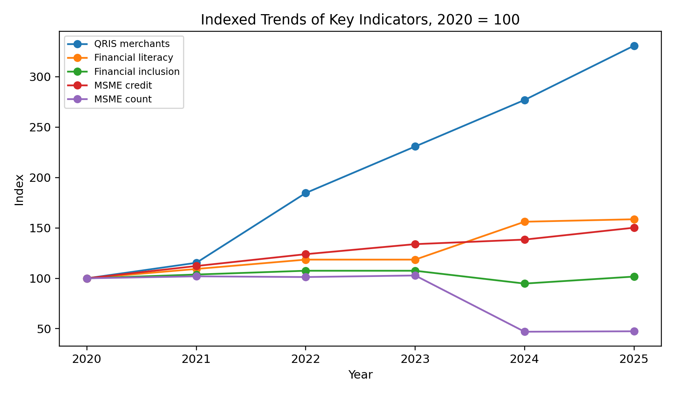
Figure 1. Indexed trends of key indicators, 2020-2025
Source: Author calculations from Table 2; 2020 = 100.
Figure 1 exposes an important asymmetry. QRIS merchant access expanded far more rapidly than the other indicators, while MSME credit rose steadily but less dramatically. The financial-literacy index accelerated in 2024, whereas financial inclusion was more volatile. The sharp statistical break in the MSME-count series confirms that administrative indicators should not be interpreted as if they were uninterrupted measures of business survival or firm creation.

4.2 Growth-Rate Analysis
Table 3. Year-on-year growth rates, percent
Year | QRIS merchants | Financial literacy | Financial inclusion | MSME credit | MSME count
2020 | n.a. | n.a. | n.a. | n.a. | n.a.
2021 | 15.38 | 9.28 | 3.75 | 12.19 | 1.96
2022 | 60.00 | 8.47 | 3.62 | 10.47 | -0.70
2023 | 25.00 | 0.00 | 0.00 | 8.03 | 1.54
2024 | 20.00 | 31.70 | -11.84 | 3.37 | -54.27
2025 | 19.44 | 1.57 | 7.32 | 8.52 | 0.93
Source: Author calculations from Table 2. The 2025 MSME rates are estimate-based.

QRIS merchant growth peaked at 60.00 percent in 2022, then moderated to 25.00 percent in 2023, 20.00 percent in 2024, and 19.44 percent in 2025. This deceleration is consistent with network diffusion rather than deterioration: percentage growth normally slows as the installed merchant base becomes larger. The system nevertheless added seven million merchants during 2025, showing that a lower growth rate can coexist with substantial absolute expansion.
MSME credit followed a smoother trajectory, but its growth slowed from 12.19 percent in 2021 to 3.37 percent in 2024. The analytical 2025 estimate implies growth of 8.52 percent. Financial literacy grew sharply in 2024 and only modestly in 2025, while financial inclusion rebounded by 7.32 percent after its 2024 decline. The MSME-count contraction in 2024 is best treated as a structural data break. Interpreting it as the disappearance of more than half of all MSMEs would be empirically implausible and would contaminate substantive conclusions.
The combined pattern suggests that Indonesia has been more successful at scaling payment acceptance than at demonstrating equivalent progress in financing depth, capability application, or firm-level outcomes. This distinction is central to the article: access is an input into scalability, not evidence of scalability itself.

4.3 National Correlation Analysis
Table 4. Pearson correlations between QRIS merchants and selected national indicators, 2020-2025
Indicator paired with QRIS merchants | Correlation coefficient | Interpretation
MSME credit | 0.982 | Very strong positive association; partly affected by the estimated 2025 value.
Financial literacy index | 0.936 | Very strong positive association; capability and merchant access rose together.
Financial inclusion index | -0.217 | Weak negative association; the 2024 decline dominates the short series.
Number of MSMEs | -0.819 | Strong negative association; driven by the 2024 administrative break.
Source: Author calculations. Six annual observations are used; the MSME series includes analytical 2025 estimates.
The strongest association is between QRIS merchants and MSME credit (r = 0.982), followed by financial literacy (r = 0.936). These coefficients show that payment acceptance, formal MSME financing, and literacy indicators moved in broadly compatible directions. They do not demonstrate that QRIS caused credit growth or capability improvement. Common time trends, policy expansion, economic recovery, and measurement choices can generate high correlations even in the absence of a direct causal mechanism.
The financial-inclusion correlation is weak and negative (r = -0.217), primarily because the index declined in 2024 while QRIS merchants continued to increase. The correlation with the MSME count is strongly negative (r = -0.819), but this result is not economically credible as a structural relationship because it is dominated by the 2024 change in the administrative series. Table 4 should therefore be read as a diagnostic sensitivity exercise rather than as hypothesis-testing evidence.

4.4 Provincial QRIS Merchant Concentration, Q2 2025
The provincial data record approximately 39.31 million QRIS merchants on 30 June 2025. West Java led with 8.38 million merchants, followed by Jakarta with 6.17 million, East Java with 4.66 million, Central Java with 3.99 million, and Banten with 2.35 million. Together, these five provinces represented 64.99 percent of the provincial total. The ten largest provinces accounted for 79.41 percent, demonstrating that national access remains territorially concentrated.
The concentration measures confirm this pattern. The HHI is 1048 on a 0-10,000 scale and the provincial Gini coefficient is 0.685. The HHI does not imply a monopolistic payment market because the units are geographic shares rather than competing firms; instead, it summarizes spatial concentration. The Gini coefficient shows that merchant access is distributed unevenly across provinces, with the smallest provincial networks concentrated in the newly separated Papua provinces.
Table 5. Complete provincial QRIS merchant dataset
Province | Merchants (million) | Share (%) | Tier
West Java | 8.380 | 21.32 | Tier 1
Jakarta | 6.170 | 15.69 | Tier 1
East Java | 4.660 | 11.85 | Tier 1
Central Java | 3.990 | 10.15 | Tier 1
Banten | 2.350 | 5.98 | Tier 1
North Sumatra | 1.500 | 3.82 | Tier 1
South Sulawesi | 1.230 | 3.13 | Tier 1
South Sumatra | 1.000 | 2.54 | Tier 1
Bali | 0.996 | 2.53 | Tier 1
DI Yogyakarta | 0.941 | 2.39 | Tier 1
Riau | 0.822 | 2.09 | Tier 2
East Kalimantan | 0.703 | 1.79 | Tier 2
Lampung | 0.696 | 1.77 | Tier 2
Riau Islands | 0.631 | 1.61 | Tier 2
West Sumatra | 0.625 | 1.59 | Tier 2
South Kalimantan | 0.512 | 1.30 | Tier 2
West Kalimantan | 0.429 | 1.09 | Tier 2
Jambi | 0.388 | 0.99 | Tier 2
West Nusa Tenggara | 0.369 | 0.94 | Tier 2
Central Kalimantan | 0.348 | 0.89 | Tier 3
North Sulawesi | 0.332 | 0.84 | Tier 3
East Nusa Tenggara | 0.282 | 0.72 | Tier 3
Central Sulawesi | 0.256 | 0.65 | Tier 3
Aceh | 0.214 | 0.54 | Tier 3
Southeast Sulawesi | 0.209 | 0.53 | Tier 3
Bengkulu | 0.204 | 0.52 | Tier 3
Bangka Belitung Islands | 0.175 | 0.45 | Tier 3
Papua | 0.167 | 0.42 | Tier 3
Gorontalo | 0.132 | 0.34 | Tier 4
North Maluku | 0.127 | 0.32 | Tier 4
Maluku | 0.097 | 0.25 | Tier 4
West Sulawesi | 0.093 | 0.24 | Tier 4
North Kalimantan | 0.092 | 0.23 | Tier 4
Southwest Papua | 0.055 | 0.14 | Tier 4
West Papua | 0.055 | 0.14 | Tier 4
Central Papua | 0.042 | 0.11 | Tier 4
South Papua | 0.027 | 0.07 | Tier 4
Highland Papua | 0.013 | 0.03 | Tier 4
Source: Author calculations from the supplied ASPI/Databoks provincial dataset.
Table 6. Ten provinces with the largest QRIS merchant networks, Q2 2025
Rank | Province | Merchants (million) | Share of provincial total (%)
1 | West Java | 8.380 | 21.32
2 | Jakarta | 6.170 | 15.69
3 | East Java | 4.660 | 11.85
4 | Central Java | 3.990 | 10.15
5 | Banten | 2.350 | 5.98
6 | North Sumatra | 1.500 | 3.82
7 | South Sulawesi | 1.230 | 3.13
8 | South Sumatra | 1.000 | 2.54
9 | Bali | 0.996 | 2.53
10 | DI Yogyakarta | 0.941 | 2.39
Source: Author calculations from the supplied ASPI/Databoks provincial merchant dataset, 30 June 2025.
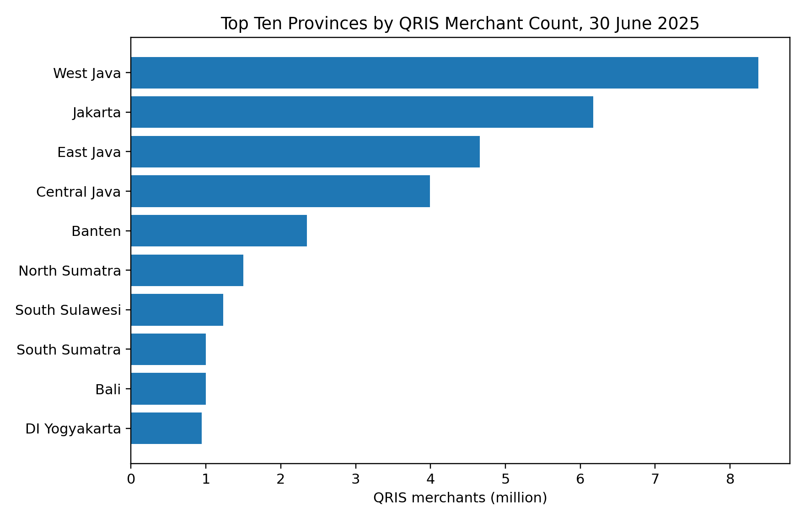
Figure 2. Top ten provinces by QRIS merchant count, 30 June 2025
Source: Author visualization based on the supplied ASPI/Databoks provincial dataset.
Concentration should not automatically be labelled a policy failure. Large provinces have bigger populations, denser retail markets, more payment-service agents, and stronger network effects. However, absolute merchant counts can conceal underdeveloped adoption intensity in smaller provinces and within rural districts of large provinces. National targets should therefore be complemented by density, active-use, and district-level indicators.

4.5 Consumer Expansion and Two-Sided Network Development
QRIS functions as a two-sided network: merchant acceptance becomes more valuable when more consumers can pay, and consumer adoption becomes more useful when more merchants accept the standard. Consumer users increased from approximately 18 million in Q1 2022 to 60 million in Q4 2025. At the end of 2025, the system served about 60 million consumers and 43 million merchants, suggesting that both sides of the network continued to widen rather than one side expanding in isolation.
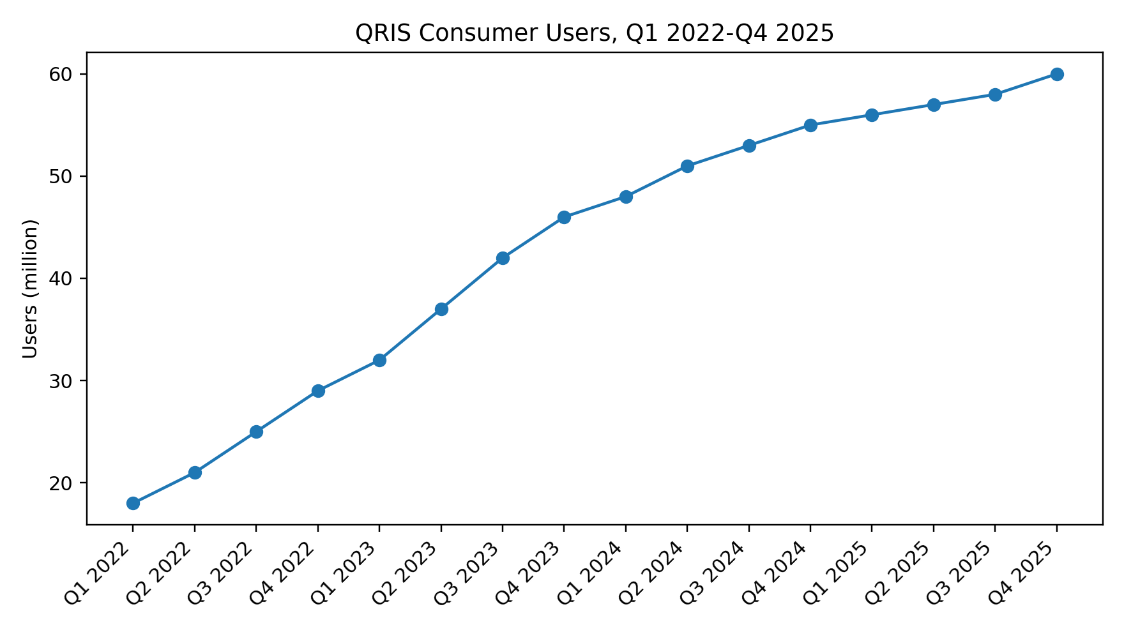
Figure 3. QRIS consumer users in Indonesia, Q1 2022-Q4 2025
Source: Author visualization based on the supplied ASPI/Databoks consumer-user dataset.
Table 7. End-of-year QRIS consumer and merchant indicators, 2022-2025
Year | Consumer users (million) | Merchants (million) | Consumers per registered merchant
2022 | 29 | 24 | 1.21
2023 | 46 | 30 | 1.53
2024 | 55 | 36 | 1.53
2025 | 60 | 43 | 1.40
Source: Compiled by the author from the supplied ASPI/Databoks user and merchant datasets.
The consumer-to-merchant ratio remained close to one, increasing from 1.21 in 2022 to 1.40 in 2025. This measure should not be interpreted as the number of customers served by each merchant because users transact with multiple merchants and registered merchants differ greatly in activity. It is nevertheless useful as a network-balance indicator. The expansion of both sides reduces the risk of a payment infrastructure with many registered outlets but insufficient consumer demand.

4.6 Transaction Intensity and Active Usage
Transaction data provide a stronger bridge between access and economic use than merchant registration alone. In Q2 2025, QRIS processed 1.19 billion transactions with a nominal value of Rp110 trillion. These figures represented year-on-year increases of 141 percent in volume and 111 percent in value. The implied Q2 2024 baselines are approximately 0.49 billion transactions and Rp52.13 trillion, respectively.
The faster growth of transaction volume than transaction value suggests that average transaction size declined as QRIS penetrated smaller and more frequent retail payments. This interpretation is consistent with the system becoming embedded in routine consumption and micro-merchant transactions. It is still an inference from aggregate data, not proof that individual MSMEs experienced higher revenue, productivity, or profitability.
Table 8. QRIS active-usage indicators, Q2 2025
Indicator | Q2 2024 implied level | Q2 2025 level | Year-on-year growth | Interpretive role
Transaction volume | 0.494 billion | 1.190 billion | 141% | Frequency and intensity of digital-payment use
Transaction value | Rp52.13 trillion | Rp110.00 trillion | 111% | Economic value routed through QRIS
Consumer users | Approximately 50.9 million | 57 million | 12% | Demand-side network reach
Registered merchants | 33 million | 39 million | 18% | Acceptance-side network reach
Source: Author calculations from the supplied ASPI/Databoks files. Q2 2024 transaction levels are implied by reversing the reported year-on-year growth rates.
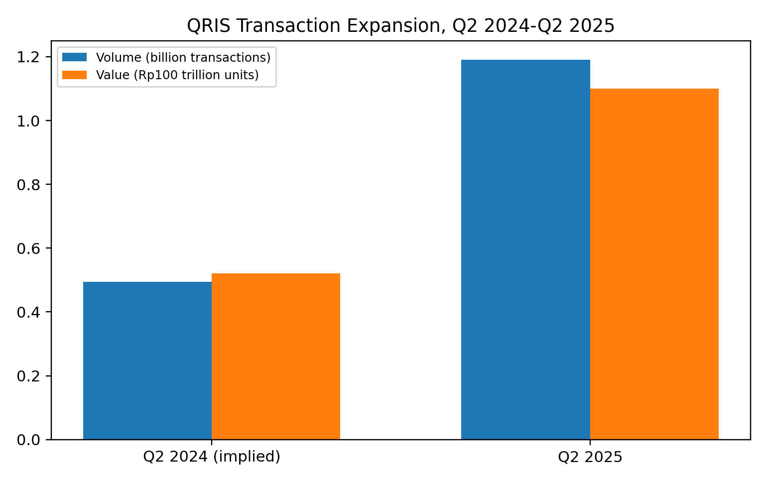
Figure 4. QRIS transaction expansion, Q2 2024-Q2 2025
Source: Author calculations from reported Q2 2025 levels and year-on-year growth rates. Transaction value is scaled in Rp100 trillion units for visual comparability.

The transaction evidence materially strengthens the article because it shows that the QRIS ecosystem expanded beyond registration. Yet it also sharpens the article’s central caution. Aggregate transaction growth cannot reveal whether benefits are widely distributed, whether merchants are active or dormant, or whether digital sales substitute for cash sales rather than creating additional turnover. A convincing scalability claim requires merchant-level evidence on sales, costs, working capital, employment, and financing outcomes.

4.7 Provincial Merchant-Ecosystem Typology
To translate the provincial distribution into an operational policy tool, provinces are grouped into four tiers using the 25th, 50th, and 75th percentiles of merchant counts. The thresholds are 0.141, 0.358, and 0.911 million merchants. This quartile-based classification avoids an arbitrary national cut-off and recognizes the highly skewed distribution. It is a diagnostic segmentation, not a ranking of government performance or MSME quality.
Table 9. Provincial QRIS merchant-ecosystem typology, Q2 2025
Tier | Number of provinces | Provinces | Priority
Tier 1: large-scale ecosystems | 10 | West Java, Jakarta, East Java, Central Java, Banten, North Sumatra, South Sulawesi, South Sumatra, Bali, DI Yogyakarta | Shift from onboarding to active-use quality, transaction-data portability, credit-readiness pilots, and merchant protection.
Tier 2: expanding ecosystems | 9 | Riau, East Kalimantan, Lampung, Riau Islands, West Sumatra, South Kalimantan, West Kalimantan, Jambi, West Nusa Tenggara | Deepen usage, improve sector-specific onboarding, and connect transaction records to formal bookkeeping.
Tier 3: emerging ecosystems | 9 | Central Kalimantan, North Sulawesi, East Nusa Tenggara, Central Sulawesi, Aceh, Southeast Sulawesi, Bengkulu, Bangka Belitung Islands, Papua | Combine merchant acquisition with assisted use, local consumer campaigns, and digital capability support.
Tier 4: foundational ecosystems | 10 | Gorontalo, North Maluku, Maluku, West Sulawesi, North Kalimantan, Southwest Papua, West Papua, Central Papua, South Papua, Highland Papua | Prioritize connectivity, agent support, basic literacy, dispute resolution, and low-cost onboarding.
Source: Author classification using quartiles of the supplied provincial merchant counts.
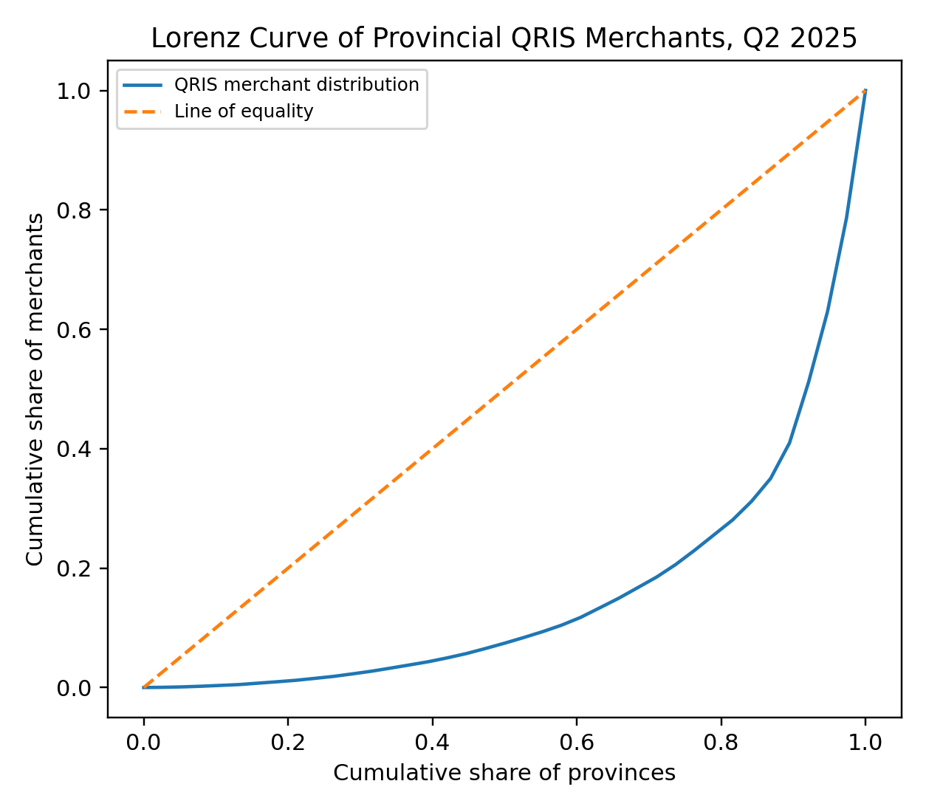
Figure 5. Lorenz curve of provincial QRIS merchant distribution, Q2 2025
Source: Author calculations from the supplied provincial QRIS merchant dataset.

Tier 1 provinces are suitable for second-stage interventions because a large acceptance network already exists. The policy question is no longer how many QR codes have been issued, but how many merchants transact regularly, maintain reliable records, and convert those records into better financial decisions. Tier 4 provinces require a different sequence: infrastructure, assisted onboarding, trust, and consumer protection must precede sophisticated credit-data use.

4.8 Discussion: From Access Expansion to MSME Scalability
The revised evidence supports an access-usage-capability-scale framework. Merchant and consumer numbers represent access and network reach. Transaction volume and value represent aggregate usage. Financial literacy indicates a capability environment, while MSME credit captures one dimension of formal financing. None of these indicators alone measures scalability, but together they show whether the ecosystem is developing the conditions under which scalability can become more feasible.
Three findings are especially important. First, the payment network expanded rapidly on both the merchant and consumer sides. Second, transaction activity grew much faster than network membership in Q2 2025, indicating that use intensified rather than merely tracking registrations. Third, access remains geographically concentrated. The combination implies that Indonesia has moved beyond the first stage of digital-payment diffusion, but the benefits are unlikely to be uniform across regions or merchant types.
For MSMEs, QRIS can support scalability through lower cash-handling costs, broader payment choice, transaction documentation, faster reconciliation, and potential integration with financing. These channels are conditional. A merchant must separate business and household funds, understand settlement timing and fees, maintain accurate records, protect account credentials, and use transaction information for inventory and cash-flow decisions. Without these practices, QRIS remains a convenient acceptance instrument rather than a business-upgrading technology.
For lenders and payment providers, transaction records may reduce information asymmetry by showing turnover regularity and cash-flow patterns. However, aggregate national growth does not validate individual creditworthiness. Any use of QRIS data in underwriting should be consent-based, purpose-limited, auditable, and combined with prudent affordability assessment. Otherwise, the same infrastructure that improves access could generate privacy risks, algorithmic exclusion, or over-indebtedness.
The policy implication is a change in the unit of success. Registration totals remain useful for measuring reach, but the next phase should monitor active merchants, transaction regularity, settlement reliability, complaint resolution, bookkeeping adoption, financing conversion, and business outcomes. The article therefore does not claim that QRIS has already created MSME economies of scale. It concludes that QRIS has built a substantial access and usage layer whose conversion into scalable MSME performance depends on capability, governance, finance, and regional implementation.

5. Conclusion
This study evaluates Indonesia’s QRIS ecosystem through national trends, provincial concentration, consumer-network growth, transaction activity, financial capability, and MSME financing indicators. Registered merchants increased from 13.0 million in 2020 to 43.0 million in 2025, while consumer users reached approximately 60 million by Q4 2025. At the usage level, Q2 2025 recorded 1.19 billion transactions worth Rp110 trillion, representing year-on-year growth of 141 percent and 111 percent, respectively.
The provincial evidence reveals substantial spatial concentration. The ten largest provinces accounted for 79.41 percent of provincial merchants, the HHI was approximately 1048, and the Gini coefficient was 0.685. These findings show that national QRIS expansion is not geographically uniform. Large networks in Java and major urban economies coexist with much smaller ecosystems in eastern and newly separated provinces.
The national correlations show that QRIS merchant expansion moved closely with MSME credit and financial literacy, but the short series and the inclusion of estimated 2025 MSME values prevent causal interpretation. The financial-inclusion and MSME-count series also contain volatility and measurement discontinuities. The central conclusion is therefore conditional: QRIS has become a necessary access and usage infrastructure, but it is not sufficient evidence of MSME scalability.
Scalability requires the payment layer to be connected to financial management, reliable transaction records, appropriate credit, data protection, merchant capability, consumer trust, and regionally differentiated implementation. Policy should consequently move from counting access points toward measuring productive, safe, and sustained use.
5.1 Limitations and Future Research
First, the national annual series is short. Six observations cannot support robust causal inference, and high correlations may reflect common trends rather than structural relationships. Second, the 2025 MSME credit and MSME-count values are analytical estimates introduced for continuity; they should be replaced when official comparable data become available.
Third, registered merchants are not equivalent to active merchants. The aggregate transaction data improve the analysis of usage, but they do not identify the distribution of activity across merchant sizes, sectors, or regions. Fourth, provincial merchant counts are absolute values. Large-population provinces naturally dominate, so future studies should calculate merchants per 1,000 MSMEs, users per capita, transaction value per merchant, and active-merchant ratios.
Fifth, transaction growth does not automatically represent additional business growth. Digital payments may substitute for cash without increasing total sales. Merchant-level panel data are needed to test effects on revenue, costs, inventory turnover, employment, survival, credit access, and productivity. Future research should also distinguish micro, small, and medium firms and compare urban and rural merchants.
Finally, stronger designs should combine administrative data with surveys, interviews, or quasi-experimental methods. A provincial or district panel could test whether improvements in connectivity, literacy, active QRIS use, and financing precede measurable business outcomes. Experimental pilots could evaluate QRIS-based bookkeeping support, credit-readiness training, and consent-based data portability.

6. Policy Recommendations

6.1 Replace Registration-Only Targets with an Inclusion-Quality Dashboard
Bank Indonesia should lead the development of a national Inclusion-Quality Dashboard, with OJK, ASPI, payment service providers, banks, fintech firms, and MSME agencies supplying harmonized indicators. The dashboard should distinguish registered merchants from merchants that transact at least once within a defined reporting period and should separately report transaction frequency, median transaction value, settlement reliability, complaint incidence, and merchant retention. This recommendation is an immediate priority because the present evidence shows that merchant registration and transaction activity are not interchangeable measures. Core indicators should include the active-merchant ratio, median monthly transaction frequency, settlement-failure rate, median complaint-resolution time, and twelve-month merchant-retention rate. Public reporting should protect confidentiality while still permitting comparison across provinces, sectors, and merchant-size categories.

6.2 Build QRIS-Based MSME Financial-Management and Credit-Readiness Programs
OJK should coordinate a national QRIS-based MSME financial-management and credit-readiness program with banks, fintech lenders, payment providers, local governments, and MSME support institutions. The program should use standardized merchant transaction summaries to teach daily reconciliation, separation of household and business funds, cash-flow forecasting, inventory planning, pricing, fraud prevention, and responsible borrowing. Participation should not automatically trigger a credit offer; the purpose is to improve business capability before financing decisions are made. Pilot evaluation should track bookkeeping adoption, the share of participants maintaining separate business accounts, the quality of loan applications, approval and rejection rates, repayment performance, and changes in working-capital management. Priority should be given to micro and small firms that already accept QRIS but lack reliable financial records.

6.3 Develop Consent-Based and Purpose-Limited Transaction-Data Portability
A consent-based transaction-data portability framework should allow MSMEs to share standardized QRIS transaction summaries with licensed financial institutions without surrendering unrestricted access to raw account data. Bank Indonesia and OJK should jointly define the data fields, consent language, permitted purposes, retention periods, security standards, audit trails, correction procedures, and revocation rights. Data should be shared only for a clearly stated purpose and for a limited period, and refusal to share should not automatically exclude a merchant from conventional assessment. The framework should also require plain-language explanations, breach notification, and effective complaint mechanisms. Success should be measured through consent-completion rates, withdrawal rates, data-correction requests, privacy incidents, processing time, and the proportion of applications assessed through both digital and conventional evidence.

6.4 Differentiate Provincial Intervention by Ecosystem Tier
Provincial intervention should follow the ecosystem tiers identified in Section 4.7 rather than apply a uniform national target. Tier 1 provinces should move from onboarding toward active-use quality, transaction-data pilots, sector-specific credit readiness, and advanced merchant protection. Tier 2 provinces should deepen usage and integrate QRIS records with bookkeeping support. Tier 3 provinces require assisted onboarding, local consumer activation, and practical digital capability programs. Tier 4 provinces need foundational connectivity, local agents, basic literacy, low-cost onboarding, and accessible dispute resolution before advanced credit-data initiatives are introduced. Bank Indonesia regional offices and OJK regional offices should work with provincial governments to prepare annual action plans using common indicators but different intervention sequences.

6.5 Protect Merchants as a Condition of Inclusion
Merchant protection should be treated as an enabling condition for sustained inclusion rather than as a separate compliance exercise. Payment providers should publish clear information on fees, settlement timing, refunds, failed-payment procedures, account security, and complaint escalation. OJK and Bank Indonesia should establish service-level expectations for acknowledgement, investigation, and resolution of merchant complaints, with stronger requirements for account takeover, social-engineering fraud, disputed payments, and delayed settlement. Providers should also maintain simple multilingual guidance suitable for micro merchants. Key indicators should include complaint incidence per 10,000 active merchants, median resolution time, repeat-complaint rates, fraud-loss recovery, and the share of merchants who understand the available redress channels.

6.6 Test QRIS-Based Credit Scoring through a Supervised Regulatory Sandbox
A supervised regulatory sandbox should test whether QRIS transaction summaries can improve MSME credit assessment without increasing over-indebtedness, privacy risk, or discriminatory exclusion. The sandbox should include banks, licensed fintech lenders, payment providers, consumer-protection representatives, and MSME agencies under regulator-defined safeguards. Transaction data must not be the sole basis for automated rejection, and adverse decisions should be subject to human review and explanation. Models should undergo bias testing, model-drift monitoring, affordability assessment, and independent audit. Evaluation should compare approval rates, pricing, processing time, repayment, default, complaints, consent withdrawal, model error, and business outcomes against a suitable control or benchmark group.

6.7 Publish Active-Use and Distributional Statistics
Public statistics should distinguish network reach from actual economic use. Bank Indonesia and ASPI should publish regular indicators on active and dormant merchants, transaction-frequency distributions, median transaction values, concentration by province and sector, and the share of merchants with sustained activity over time. Where confidentiality allows, reporting should also distinguish micro, small, and medium enterprises and provide urban-rural breakdowns. Distributional measures are essential because national totals can rise while activity remains concentrated among a relatively small group of merchants. A minimum publication standard should include definitions, coverage, revisions, missing-data treatment, and comparability notes so that researchers and policymakers can interpret trends consistently.

6.8 Link QRIS Policy to Measurable MSME Scalability Outcomes
The long-term objective of QRIS policy should be measurable MSME scalability rather than payment adoption alone. OJK, Bank Indonesia, BPS, the Ministry of Cooperatives and SMEs, and participating financial institutions should develop a longitudinal evaluation framework linking QRIS use to sales stability, inventory turnover, market reach, formal financing access, productivity, employment, business survival, and resilience to shocks. These outcomes should be assessed with merchant-level panel data and appropriate comparison groups wherever feasible. The framework should explicitly distinguish additional business growth from the substitution of cash transactions by digital payments. QRIS should be considered economically transformative only when sustained use is associated with better business decisions and verifiable improvements in firm performance.

Table 10. Implementation roadmap for the proposed QRIS–MSME policy package
Priority action | Lead institution | Supporting institutions | Implementation horizon | Core success indicators
Inclusion-quality dashboard | Bank Indonesia | OJK, ASPI, providers, MSME agencies | Immediate (0–12 months) | Active-merchant ratio; transaction frequency; settlement failure; complaint resolution
Financial-management and credit-readiness program | OJK | BI, banks, fintech, local governments | Medium term (6–24 months) | Bookkeeping adoption; separate accounts; application quality; repayment performance
Consent-based data portability | BI and OJK | Providers, banks, fintech, data-protection authorities | Medium to long term (12–36 months) | Valid consent; revocation; correction requests; privacy incidents; assessment time
Tier-based provincial delivery | BI/OJK regional offices | Provincial governments, MSME agencies, providers | Immediate and continuous | Active-use growth by tier; rural participation; merchant retention
Merchant protection standards | BI and OJK | Providers, banks, consumer-protection bodies | Immediate (0–12 months) | Complaint incidence; resolution time; fraud recovery; merchant awareness
Supervised credit-scoring sandbox | OJK | BI, banks, fintech, providers, MSME representatives | Pilot (12–24 months) | Approval quality; pricing; default; bias; complaints; business outcomes
Distributional public statistics | BI and ASPI | OJK, BPS, providers | Immediate and recurring | Active/dormant split; medians; provincial and sector distributions
MSME scalability evaluation | OJK, BI, BPS, Ministry of Cooperatives and SMEs | Financial institutions, researchers, local governments | Long term (24–60 months) | Sales stability; productivity; employment; survival; financing access
Source: Author formulation based on the empirical findings of this study.
Taken together, the recommendations form a sequenced policy package. Measurement and protection should begin immediately; capability-building and provincial delivery should follow with clear operational targets; and data-driven credit innovation should proceed only through supervised testing. This sequence reduces the risk that rapid digital access will be mistaken for economic empowerment and aligns implementation with the article’s central finding that scalability depends on the conversion of access into productive use.

7. Disclosure
Conflict of interest. The author declares no financial, professional, or personal conflict of interest that could have influenced the design, analysis, interpretation, or presentation of this study.
Funding. This study received no external financial support. No public institution, private firm, payment service provider, lender, or competition organizer participated in the analysis or influenced the conclusions.
Author contribution. The author was solely responsible for conceptualization, research design, data compilation, data validation, calculation, visualization, interpretation, manuscript drafting, and final revision.
Acknowledgements. The author acknowledges the publicly available statistics, policy documents, and institutional materials issued by Bank Indonesia, OJK, BPS, the Ministry of Cooperatives and SMEs, ASPI, and Databoks. Acknowledgement does not imply endorsement of the analysis or conclusions by those institutions.
Data availability. The study uses publicly available aggregate data and author-reconstructed analytical datasets. The calculation tables and reproducible analytical file may be provided upon reasonable request. Original source data remain subject to the terms, definitions, revisions, and intellectual-property conditions of their respective providers.
Originality and research integrity. This manuscript presents an original analysis and synthesis prepared specifically for this study. All external concepts, methods, statistics, and datasets are acknowledged through citation. No institution or data provider is represented as having verified the author’s calculations unless explicitly stated.
Use of estimates and derived values. The 2025 MSME credit and MSME-count figures are analytical estimates used to maintain the 2020–2025 comparison frame. The implied Q2 2024 transaction values are derived by reversing reported year-on-year growth rates. These values are identified throughout the manuscript and should be replaced or recalculated when official comparable observations become available.
Ethics and data protection. The study relies exclusively on aggregate secondary data and does not involve human participants, personal identifiers, or confidential account-level information. Consequently, no individual consent or institutional ethics review was required for the present analysis.

8. References
Allen, F., Demirguc-Kunt, A., Klapper, L., & Martinez Peria, M. S. (2016). The foundations of financial inclusion: Understanding ownership and use of formal accounts. Journal of Financial Intermediation, 27, 1–30. https://doi.org/10.1016/j.jfi.2015.12.003
Arner, D. W., Buckley, R. P., Zetzsche, D. A., & Veidt, R. (2020). Sustainability, FinTech and Financial Inclusion. European Business Organization Law Review, 21(1), 7–35. https://doi.org/10.1007/s40804-020-00183-y
Ayyagari, M., Demirguc-Kunt, A., & Maksimovic, V. (2014). Who creates jobs in developing countries? Small Business Economics, 43(1), 75–99. https://doi.org/10.1007/s11187-014-9549-5
Beck, T., Demirguc‐Kunt, A., & Maksimovic, V. (2005). Financial and Legal Constraints to Growth: Does Firm Size Matter? The Journal of Finance, 60(1), 137–177. https://doi.org/10.1111/j.1540-6261.2005.00727.x
Berger, A. N., & Udell, G. F. (2006). A more complete conceptual framework for SME finance. Journal of Banking & Finance, 30(11), 2945–2966. https://doi.org/10.1016/j.jbankfin.2006.05.008
BI. (2019). Blueprint Sistem Pembayaran Indonesia 2025: Menavigasi sistem pembayaran nasional di era digital [Indonesia Payment System Blueprint 2025: Navigating the national payment system in the digital era]. https://www.bi.go.id/id/fungsi-utama/sistem-pembayaran/blueprint-2025/Default.aspx
BI. (2024). Data perkembangan jumlah merchant Quick Response Code Indonesian Standard (QRIS) di Indonesia periode 2020-2024.
BPS. (2024). Persentase penduduk berumur 5 tahun ke atas yang mengakses internet dalam 3 bulan terakhir menurut provinsi.
Cowell, F. (2011). Measuring Inequality. Oxford University Press. https://doi.org/10.1093/acprof:osobl/9780199594030.001.0001
Damodar N. Gujarati, D. C. P. (2009). Basic Econometrics. In McGraw-Hill Irwin (Fourth Edi, p. 922).
Databoks katadata. (2024). Statistik adopsi infrastruktur pembayaran digital dan agregasi merchant QRIS nasional.
Demirguc-Kunt, A., & Klapper, L. (2012). Measuring Financial Inclusion: The Global Findex Database. World Bank, Washington, DC. https://doi.org/10.1596/1813-9450-6025
Frame, W. S., Srinivasan, A., & Woosley, L. (2001). The Effect of Credit Scoring on Small-Business Lending. Journal of Money, Credit and Banking, 33(3), 813. https://doi.org/10.2307/2673896
Gomber, P., Kauffman, R. J., Parker, C., & Weber, B. W. (2018). On the Fintech Revolution: Interpreting the Forces of Innovation, Disruption, and Transformation in Financial Services. Journal of Management Information Systems, 35(1), 220–265. https://doi.org/10.1080/07421222.2018.1440766
Grohmann, A., Klühs, T., & Menkhoff, L. (2018). Does financial literacy improve financial inclusion? Cross country evidence. World Development, 111, 84–96. https://doi.org/10.1016/j.worlddev.2018.06.020
Hirschmann, A. (1964). The Paternity of an Index. American Economic Review, 54, 761.
Indonesia, K. K. dan U. K. dan M. R. (2024). Laporan data perkembangan usaha mikro, kecil, dan menengah (UMKM) di Indonesia tahun 2020-2024.
Informatika, K. K. dan. (2021). Peta Jalan Indonesia Digital 2021-2024 [Indonesia Digital Roadmap 2021-2024]. https://www.kominfo.go.id/
Jack, W., & Suri, T. (2014). Risk Sharing and Transactions Costs: Evidence from Kenya’s Mobile Money Revolution. American Economic Review, 104(1), 183–223. https://doi.org/10.1257/aer.104.1.183
Jagtiani, J., & Lemieux, C. (2019). The roles of alternative data and machine learning in fintech lending: Evidence from the LendingClub consumer platform. Financial Management, 48(4), 1009–1029. https://doi.org/10.1111/fima.12295
Joseph F Hair, Barry J. Babin, Rolph E. Anderson, W. C. B. (2022). Multivariate Data Analysis. In Cengage Learning (8th ed, p. 832).
Klapper, L., Laeven, L., & Rajan, R. (2006). Entry regulation as a barrier to entrepreneurship. Journal of Financial Economics, 82(3), 591–629. https://doi.org/10.1016/j.jfineco.2005.09.006
Lusardi, A., & Mitchell, O. S. (2014). The Economic Importance of Financial Literacy: Theory and Evidence. Journal of Economic Literature, 52(1), 5–44. https://doi.org/10.1257/jel.52.1.5
Morgan, P. J., & Long, T. Q. (2020). Financial literacy, financial inclusion, and savings behavior in Laos. Journal of Asian Economics, 68, 101197. https://doi.org/10.1016/j.asieco.2020.101197
Murfin, J., & Spiegel, M. (2020). Is the Risk of Sea Level Rise Capitalized in Residential Real Estate? The Review of Financial Studies, 33(3), 1217–1255. https://doi.org/10.1093/rfs/hhz134
OJK. (2024a). Hasil Survei Nasional Literasi dan Inklusi Keuangan (SNLIK) 2024.
OJK. (2024b). Survei Nasional Literasi dan Inklusi Keuangan (SNLIK) 2024. https://ojk.go.id/id/berita-dan-kegiatan/publikasi/Pages/Survei-Nasional-Literasi-dan-Inklusi-Keuangan-(SNLIK)-2024.aspx
OJK. (2026). Sosialisasi Kegiatan KARISMA OJK Paper Award 2026. https://www.karismaojki.com/pengumuman
Perekonomian, K. K. B. (2021). Strategi Nasional Ekonomi Digital Indonesia 2030 [National Strategy for Indonesian Digital Economy 2030]. https://ekon.go.id/
Petersen, M. A., & Rajan, R. G. (1994). The Benefits of Lending Relationships: Evidence from Small Business Data. The Journal of Finance, 49(1), 3–37. https://doi.org/10.1111/j.1540-6261.1994.tb04418.x
Suri, T. (2017). Mobile Money. Annual Review of Economics, 9(1), 497–520. https://doi.org/10.1146/annurev-economics-063016-103638
Suri, T., & Jack, W. (2016). The long-run poverty and gender impacts of mobile money. Science, 354(6317), 1288–1292. https://doi.org/10.1126/science.aah5309
van Rooij, M., Lusardi, A., & Alessie, R. (2011). Financial literacy and stock market participation. Journal of Financial Economics, 101(2), 449–472. https://doi.org/10.1016/j.jfineco.2011.03.006
Voordeckers, W., & Steijvers, T. (2006). Business collateral and personal commitments in SME lending. Journal of Banking & Finance, 30(11), 3067–3086. https://doi.org/10.1016/j.jbankfin.2006.05.003
Weiss, J. E. S. A. (1981). Credit Rationing in Markets with Imperfect Information. The American Economic Review, 71(3), 393–410.
Wooldridge, J. M. (2020). Introductory Econometrics: A Modern Approach. In Cengage Learning (7th ed, p. 848).

Appendix

Appendix A. Calculation and interpretation notes
The provincial total obtained by summing the displayed province values is 39.312 million merchants. Minor differences from a rounded national total of 39 million arise from rounding in the source chart.
The HHI is calculated from provincial percentage shares. It is used here as a spatial-concentration statistic and not as a competition-law measure of payment-service-provider concentration.
The Gini coefficient summarizes inequality in absolute provincial merchant counts. It does not adjust for population, number of MSMEs, economic size, or urbanization.
The Q2 2024 transaction volume and value are implied by reversing the reported Q2 2025 year-on-year growth rates: Q2 2024 = Q2 2025 / (1 + growth rate).
The consumer series is transcribed from the supplied quarterly chart and reported in rounded millions. It is suitable for descriptive visualization but not for precision econometrics.
The 2025 MSME estimates are included solely to maintain the 2020-2025 analytical frame. Correlations are exploratory and should be recalculated when official comparable figures become available.

